**Project Design Phase-II**

**Data Flow Diagram & User Stories**

|  |  |
| --- | --- |
| Date | 14 November 2022 |
| Team ID | PNT2022TMID52418 |
| Project Name | AI-based localization and classification of skin disease with erythema |
| Maximum Marks | 4 Marks |

**Data Flow Diagrams:**

A Data Flow Diagram (DFD) is a traditional visual representation of the information flows within a system. A neat and clear DFD can depict the right amount of the system requirement graphically. It shows how data enters and leaves the system, what changes the information, and where data is stored.

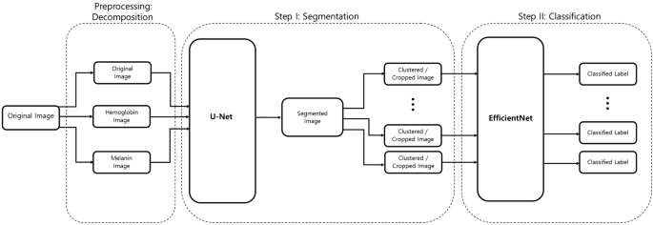

**User Stories**

Use the below template to list all the user stories for the product.

|  |  |  |  |  |  |  |
| --- | --- | --- | --- | --- | --- | --- |
| **User Type** | **Functional**  **Requirement (Epic)** | **User Story**  **Number** | **User Story / Task** | **Acceptance criteria** | **Priority** | **Release** |
| Customer  (Mobile user) | Registration | USN-1 | As a user, I can register for the application by entering my email, password, and confirming my password. | I can access my account / dashboard | High | Sprint-1 |
|  |  | USN-2 | As a user, I will receive confirmation email once I have registered for the application | I can receive confirmation email & click confirm | High | Sprint-1 |
|  |  | USN-3 | As a user, I can register for the application through Facebook | I can register & access the dashboard with Facebook Login | Low | Sprint-2 |
|  |  | USN-4 | As a user, I can register for the application through Gmail | I can register through the gmail using username and password | Medium | Sprint-1 |
|  | Login | USN-5 | As a user, I can log into the application by entering email & password | Logged in through password | High | Sprint-1 |
|  | Dashboard |  | As a user, after we enter into our application. There we see our dashboard, there it shows the visual explanation of all of our data. | By entering the username and password by the side  itself we have the dashboards. | Medium | Sprint-1 |
| Customer (Web user) | Login | USN-6 | As an individual who is authorized by the  Customer to use the Web form of the  WorkWide Technology, for whom the  Customer has purchased the Subscription Service | I receive the confirmation number | Medium | Sprint-1 |
| Customer Care Executive | Communication | USN-7 | As a user,who experts in customer service, providing highstakes customer service in large organizations and managing teams of customer care  representatives | The person should have the communication skill, problem solving etc. | High | Sprint-1 |
| Administrator | Tech support | USN-8 | **As** aadministratorwe can view and manageuserpermissionsin an application. | Only through the password of the admin | Medium | Sprint-1 |
| **User Type** | **Functional**  **Requirement (Epic)** | **User Story**  **Number** | **User Story / Task** | **Acceptance criteria** | **Priority** | **Release** |
|  |  |  |  | and get enter into the application |  |  |